MYOCARDIAL INFARCTION

Udit Sethi 2001EE93

**1. Abstract:**

Myocardial infarction (MI), commonly known as a heart attack, can cause nonrecoverable impairment to the cardiac muscles, which may even result in fatality. Therefore, it is crucial to diagnose MI accurately and reliably. This article proposes a novel framework for detecting MI using a 12-channel Electrocardiogram (ECG) signal. The method filters the signal to eliminate motion artefacts and high-frequency noise, followed by the extraction of novel spectral texture patterns and Mel frequency cepstral coefficients (MFCCs) from all ECG signal channels. These features are combined to form a comprehensive feature representation. ANOVA is then applied to reduce feature dimensions, and various state-of-the-art classification methods such as support vector machines (SVM), Artificial Neural Networks (ANN), AdaBoost (AB), and K-nearest neighbours (KNN) are utilized. The AB classifier achieved the highest performance with 98.7% accuracy and 98.4% recall using 10-fold cross-validation. The proposed method is reliable and holds the potential for clinical adoption in hospitals.

**2. Introduction:**

Insufficient oxygen supply to one or more heart muscles leads to myocardial infarction. This condition arises due to a blockage in the coronary artery, which obstructs blood flow to the heart muscle. As a consequence, the affected heart muscle dies. Henceforth, the location of a dead heart muscle corresponds to the location of a blocked coronary artery. In 2019, coronary artery disease (CVDs) caused an estimated 17.9 million deaths worldwide, making up approximately 32% of all global deaths, as reported by the World Health Organization (WHO). Almost 85% of these deaths were the result of Myocardial infarction (MI).

Fig. 1. Myocardial Infarction

**3. Background:**

An Electrocardiogram signal (ECG), a bio-signal that graphically displays the electrical activity of the heart via electrodes attached to the skin. ECG is best known for examining cardiac reactions, heartbeat skipping, amplitude, and frequency. The ECG is recorded as waves and electrical pulses in the heart. It can detect the underlying heart condition and aids cardiologists in the early detection of many problems. Cardiovascular diseases are on the rise these days for a variety of reasons. An increase in such cases leads to Myocardial infarction, also known as a heart attack. Early detection of MI can lower the risk of a heart attack and, as a result, the risk of irreversible cardiac organ failure. The damage once done by MI is permanent and cannot be overturned. Deep learning has gained popularity in recent years as a competitive technique for analyzing ECG signals [1]. The primary advantage of deep learning is its ability to learn the most distinctive features from raw data and strive to match its output with the desired outcome[2]. In one study, an 11-layer convolutional neural network (CNN) is created to automatically distinguish between normal and MI ECG beats (with and without noise) using a single-lead ECG signal. The CNN classification algorithm yielded an average accuracy of 93.53% on noisy ECG beats and 95.22% on noise-free ECG signals. However, the framework has limitations; it cannot identify the specific location of a myocardial infarction and is incompatible with a multi-lead ECG.

**4. Fundamentals:**

A. Data Set:

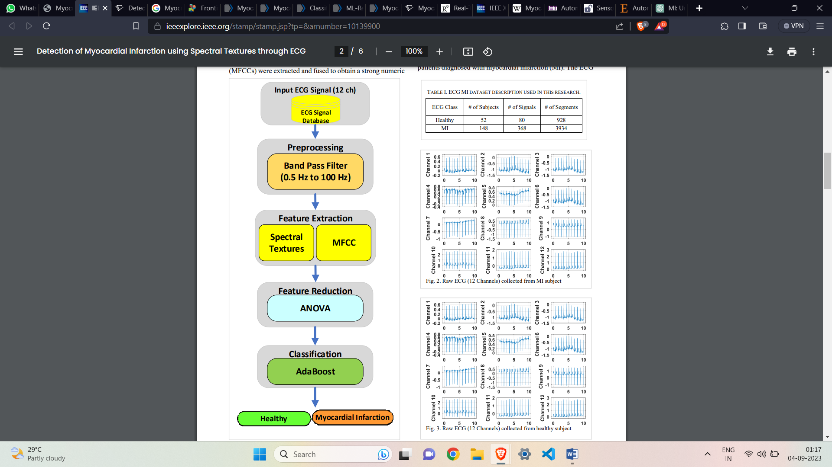 This research employs the freely accessible Physiobank PTB-ECG database [3], which contains recordings of ECG (12-Lead) readings from 52 healthy individuals and 148 patients diagnosed with myocardial infarction (MI). The ECG data is collected at a sampling rate of 1000 Hz for each lead on a 12-lead ECG. Before processing each ECG data was segmented

into 10-sec patches. The number of healthy and MI ECG signals after segmentation became 928 and 3934. To balance the number of signals across both classes, only 1000 segments of MI were used in this research. Table 1 shows the summary of the selected 12-lead ECG dataset.

B. ECG Signal Pre-processing:

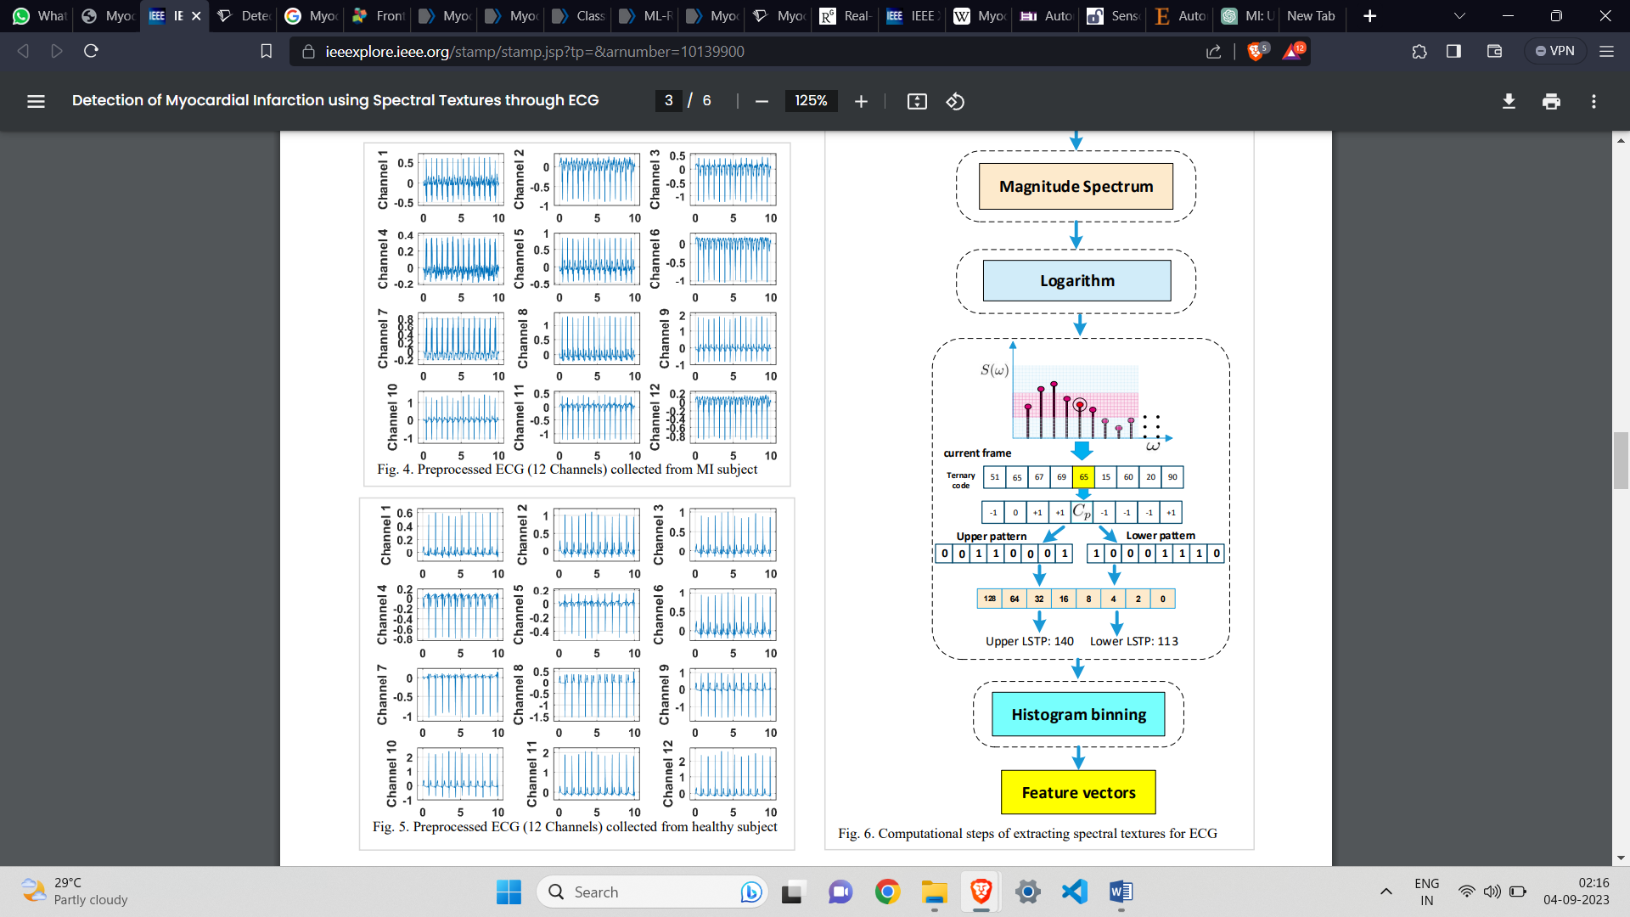Since biomedical signals often get corrupted due to motion artifacts. The high-frequency noise may also contaminate the contents of the original ECG. These contaminations fade the original information that exists in ECG related to the diagnosis of diseases. Therefore, it's very important to remove baseline wander and high-frequency noise in the data preprocessing step. We designed a 4th order IIR Butterworth bandpass filter [4]. The passband range was from 0.5 Hz to 100 Hz. Figures 2 and 3 show the raw ECG signal of the MI and healthy subjects obtained through all 12 leads. Figures 4 and 5 show filtered ECG signals of MI and healthy subjects, respectively.

C. Feature Extraction:

The purpose of feature engineering is to determine those numeric parameters from pre-processing data that can best discriminative between multiple classes. In this research, we extract spectral textures and MFCC features from pre-processed multichannel ECG signals. These features extract the most discriminant information from the signals for Healthy and MI classes.

1) Spectral Textures:

The spectral textures were obtained from all channels of preprocessed ECG signals [5]. The spectral textures were obtained by first transforming the filtered ECG signal to its frequency spectrum through Fast Fourier Transform (FFT). Next, the information spread was compressed by applying a logarithm operator. Next, the input vector was divided into frames of size L, and textural information of the logarithm of the spectral signal was obtained using ternary patterns. Ternary patterns compute two decimal values extracted from each window of the signal. These values are known as upper and lower ternary patterns. These values are obtained for all frames of the input data and compact results in the form of feature vectors are obtained using histogram bins of specific size.

2) Mel frequency cepstral coefficients (MFCCs):

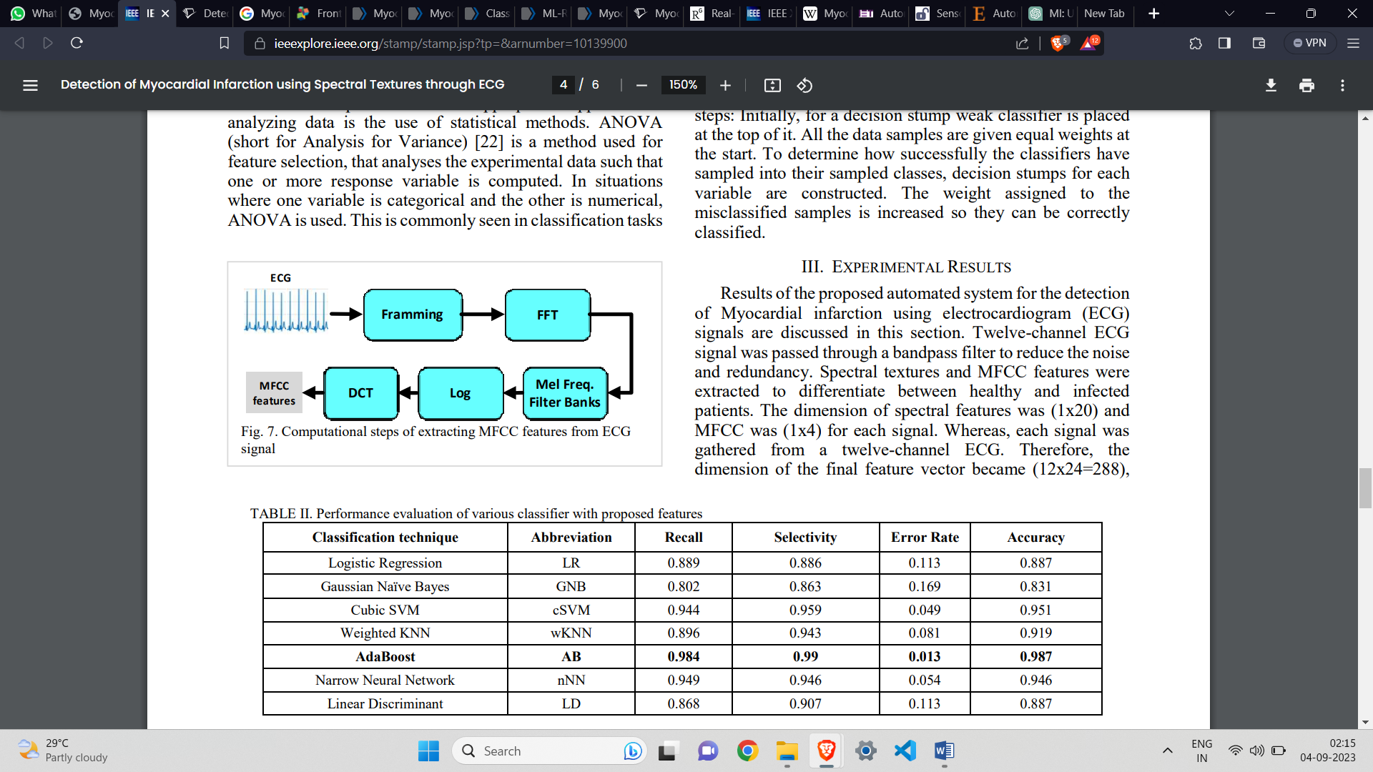Mel-frequency cepstral coefficients (MFCCs) are one of the most widely used feature extraction methods. In this research, MFCCs have been used to extract features from ECG signals. The pre-processed ECG signals are split into frames, and these frames are converged into windows while minimizing disruption. Fast Fourier Transform (FFT) is taken for conversion from a time domain to the frequency domain. Then these spectrums are passed through a filter bank that consists of a set of bandpass filters to map on a Mel-scale. The final step is to take Discrete Cosine Transform (DCT) to convert the log Mel spectrum back into the spatial domain.

*Fig. 6. Computational steps of extracting MFCC features from ECG signal*

D. ANOVA-based feature reduction:

A more sophisticated and appropriate approach to analysing data is the use of statistical methods. ANOVA (short for Analysis for Variance) is a method used for feature selection, that analyses the experimental data such that one or more response variable is computed. In situations where one variable is categorical and the other is numerical, ANOVA is used. This is commonly seen in classification tasks where the input data is numerical and the goal variable is categorical. ANOVA is a robust approach; it presupposes that all samples of data are normally distributed, with identical variance and independence and at least one group is different from others. Then, ANOVA tests the equality of group means for the data in vector.

E. Classification using AdaBoost:

AdaBoost (short for Adaptive Boosting is an ensemble learning algorithm. It is also known as a meta--learning algorithm. The method developed was intended only to improve the efficiency of binary classifiers. A single classifier may not be able to predict accurate classes singlehandedly. But when a group of weak classifiers is combined sequentially that learns from each other progressively, the final model can converge to a strong model. Therefore, it uses the conjunction of multiple classifiers and reiterates the model to learn from the inaccurate prediction of the weak classifiers and turns them into strong ones. The AdaBoost algorithm mainly uses the following four steps: Initially, for a decision stump weak classifier is placed at the top of it. All the data samples are given equal weights at the start. To determine how successfully the classifiers have sampled into their sampled classes, decision stumps for each variable are constructed. The weight assigned to the misclassified samples is increased so they can be correctly classified.

**5. Approach (Methodology):**

Figure 7 shows the proposed framework for the detection of MI using multichannel ECG signals. The proposed method consists of pre-processing, feature extraction, feature selection, and classification steps.

****In the first step, a 12- channel ECG signal is passed through a bandpass filter to remove high-frequency content and motion artefacts that may deteriorate the overall system's performance. Next, spectral texture patterns and Mel Frequency Cepstral Coefficients (MFCCs) were extracted and fused to obtain a strong numeric representation of each ECG signal. These features were extracted from all channels of pre-processed ECG signals. The dimension of extracted spectral textures was 20 and for MFCCs, it was 4. These features were obtained from each channel of pre-processed ECG signal. The Total dimension of each observation for healthy and MI ECG signals was 1x288. These high-dimensional features were analysed through ANOVA to perform feature selection and reduction. We selected the top 20 features ranked through ANOVA and fed them to a range of classification methods. The best performance was achieved using Ad boost ensemble classification.

*Fig. 7. Proposed Framework*

**6. Results:**

Results of the proposed automated system for the detection of Myocardial infarction using electrocardiogram (ECG) signals are discussed in this section. Twelve-channel ECG signal was passed through a bandpass filter to reduce the noise and redundancy. Spectral textures and MFCC features were extracted to differentiate between healthy and infected patients. The dimension of spectral features was (1x20) and MFCC was (1x4) for each signal. Whereas, each signal was gathered from a twelve-channel ECG. Therefore, the dimension of the final feature vector became (12x24=288), i.e., 1x288 feature vector. The feature vector is then reduced using the ANOVA feature reduction method, and the top 20 ranked features were selected to pass on to the classifier. The methodology was tested on a range of classifiers i.e., Logistic regression (LR), Gaussian Naive Base (GNB), Cubic SVM (cSVM), Weighted KNN (wKNN), AdaBoost (AB), Narrow Neural Network (nNN), Linear Discriminant (LD).

The accuracy, sensitivity, specificity, and error rate are calculated to examine the statistical performance of the classification learners. Here, the healthy class is the negative class whereas the MI class is positive.

Figure 8 illustrates the confusion matrix to demonstrate the overall performance of the proposed methodology. The matrix illustrates that 97.8% of the total Healthy observations were correctly classified 1.3% error rate as these observations were misclassified as MI class. Similarly, 98.7% of the total observations were correctly classified as MI class, whereas 2.2% were misclassified as Healthy class. The highest accuracy was achieved by the AdaBoost classifier with an accuracy of 98.7%, with 99% precision and 98.4% recall. The area under the curve (AUC) for the AdaBoost classifier is shown in Figure 9.

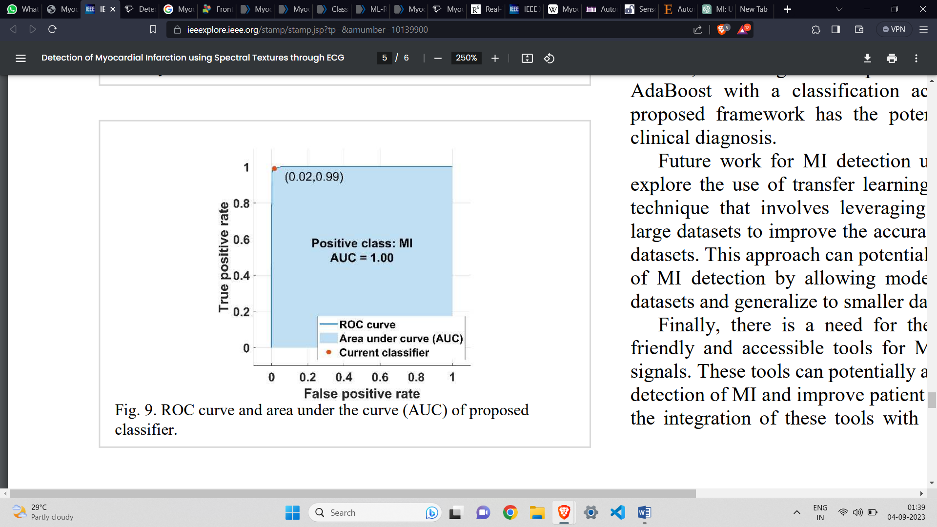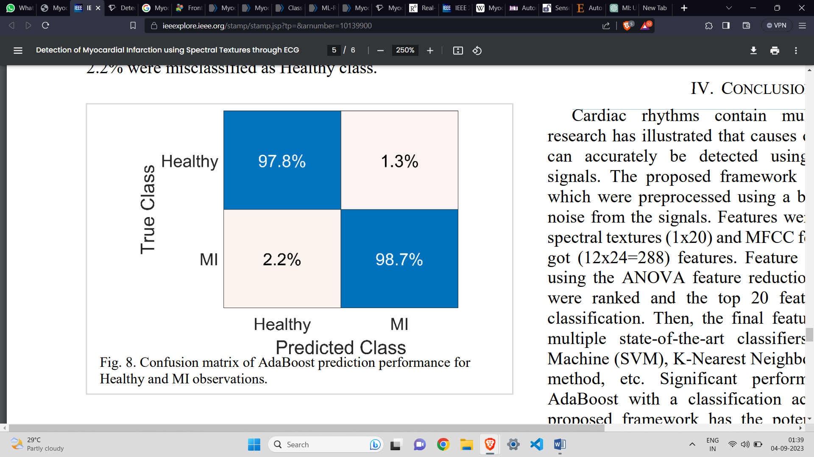*Fig. 9. ROC curve and area under the curve (AUC) of proposed classifier*

*Fig. 8. Confusion matrix of AdaBoost prediction performance for Healthy and MI observations.*

**7. Application:**

The application of the research paper has significant implications for both clinical practice and biomedical research. Following are the potential applications of this innovative approach:

1. Clinical Diagnosis and Decision Support:

One of the primary applications of this research is in clinical settings. The use of spectral textures in ECG analysis can aid healthcare professionals in the early and accurate diagnosis of myocardial infarction.

Clinicians can incorporate this approach as part of their diagnostic toolkit to enhance diagnostic accuracy and reduce the chances of misdiagnosis.

1. Telemedicine and Remote Monitoring:

The application of spectral textures through ECG analysis can be integrated into telemedicine platforms. Patients can have their ECGs recorded remotely and analysed in real-time, allowing for immediate detection of MI symptoms.

This application is particularly relevant for patients in remote or underserved areas who may not have easy access to healthcare facilities.

1. Emergency Medical Services (EMS):

EMS personnel can utilize this technology in the field to make rapid assessments of patients presenting with chest pain or related symptoms.

This can help guide decisions about the need for emergency transport to a hospital with the appropriate facilities for MI treatment.

1. Screening and Risk Assessment:

Beyond diagnosis, the spectral texture analysis could be used for population screening and risk assessment. Identifying individuals at higher risk for MI can lead to early interventions and lifestyle modifications.

Risk prediction models based on spectral texture analysis can be developed and incorporated into routine health check-ups.

1. Research and Clinical Trials:

Biomedical researchers can leverage this technology to conduct studies related to MI, cardiovascular health, and the efficacy of different treatment strategies.

The approach can be used to assess the impact of various interventions on MI detection and patient outcomes.

1. Personalized Medicine:

The application of spectral textures in MI detection may enable the development of personalized treatment plans. By understanding the unique spectral patterns of individual patients, healthcare providers can tailor treatments for optimal outcomes.

1. Continuous Monitoring and Wearable Devices:

Wearable ECG devices, such as smartwatches and patches, can incorporate spectral texture analysis to provide continuous monitoring of cardiac health.

Users can receive alerts if any abnormal spectral patterns indicative of MI are detected, allowing for timely medical intervention.

1. Education and Training:

This technology can be used for educational purposes, training medical professionals, and increasing their proficiency in MI diagnosis.

Medical students and healthcare practitioners can learn to recognize spectral patterns associated with MI and improve their diagnostic skills.

In conclusion, the application of spectral textures through ECG analysis for the detection of Myocardial Infarction has wide-ranging implications for improving healthcare outcomes, enhancing diagnostic accuracy, and advancing research in the field of cardiovascular health. It has the potential to revolutionize how MI is diagnosed, monitored, and managed, ultimately benefiting both patients and healthcare providers.

**8. Conclusion and future directions:**

Cardiac rhythms contain multiple properties. This research has illustrated that causes of myocardial infarction can accurately be detected using twelve-channel ECG signals. The proposed framework employed ECG signals which were pre-processed using a bandpass filter to reduce noise from the signals. Features were extracted using novel spectral textures (1x20) and MFCC features (1x4). Hence, we got (12x24=288) features. Feature dimension was reduced using the ANOVA feature reduction method. The features were ranked and the top 20 features were selected for classification. Then, the final feature vector was given to multiple state-of-the-art classifiers like Support Vector Machine (SVM), K-Nearest Neighbour, AdaBoost ensemble method, etc. Significant performance was shown by AdaBoost with a classification accuracy of 98.7%. The proposed framework has the potential to be adapted for clinical diagnosis.

Future work for MI detection using ECG signals is to explore the use of transfer learning. Transfer learning is a technique that involves leveraging pre-trained models on large datasets to improve the accuracy of models on smaller datasets. This approach can potentially improve the accuracy of MI detection by allowing models to learn from larger datasets and generalize to smaller datasets. Finally, there is a need for the development of user-friendly and accessible tools for MI detection using ECG signals. These tools can potentially aid clinicians in the early detection of MI and improve patient outcomes. Furthermore, the integration of these tools with electronic health record systems can potentially streamline the diagnosis and treatment process for patients with MI. Overall, there is a lot of potential for the use of machine/deep learning in MI detection using ECG signals, and further research in this field can potentially improve the accuracy of diagnosis and treatment for patients with MI.

**9. References:**

[1] H. Wang et al., "Myocardial Infarction Detection Based on Multilead Ensemble Neural Network," in 2019 41st Annual International Conference of the IEEE Engineering in Medicine and Biology Society (EMBC), 2019: IEEE, pp. 2614-2617.

[2] Y. Chen, H. Chen, Z. He, C. Yang, and Y. Cao, "Multi-channel lightweight convolution neural network for anterior myocardial infarction detection," in 2018 IEEE SmartWorld, Ubiquitous Intelligence & Computing, Advanced & Trusted Computing, Scalable Computing & Communications, Cloud & Big Data Computing, Internet of People and Smart City Innovation (SmartWorld/SCALCOM/UIC/ATC/CBDCom/IOP/SCI), 2018: IEEE, pp. 572-578.

[3] P. Database. "ECG Database." https://archive.physionet.org/physiobank/database/#ecg (accessed.

[4] S. Sarkar, S. Sarkar, and J. Mehedi, "Comprehensive Study for Selection of proper IIR filter: Specifications Dependant Approach," in 2018 3rd International Conference for Convergence in Technology (I2CT), 2018: IEEE, pp. 1-7.

[5] S. Aziz, M. U. Khan, K. Iqtidar, S. Ali, A. N. Remete, and M. A. Javid, "Pulse plethysmograph signal analysis method for classification of heart diseases using novel local spectral ternary patterns," Expert Systems, p. e13011, 2022.

This proposed approach is taken from the cited reference:-

“ https://ieeexplore.ieee.org/stamp/stamp.jsp?tp=&arnumber=10139900&tag=1”.